Project Development:

Context:
I am engaged extensively with the Fashion Business School (FBS) at LCF (London College of Fashion), primarily on the Fashion Marketing course. This intervention would be important because it would help to address the language barrier that many international students face when studying fashion marketing. The course uses a lot of jargon and acronyms, which can be difficult for students who are not familiar with the English language or the fashion industry.
Being new to university, London and in some instances Western culture can be daunting for international students. Coupling that with a new area of study such as fashion and marketing which uses countless terms and acronyms, it can be hard to keep track of them all. Additionally, some terms are not always explained in class, which can make it even more difficult to understand them. As a result, students may feel uncomfortable or shy about asking questions or investigating what these terms mean.
"Chinese graduate students often face unique challenges when transitioning to a new culture and academic environment. These challenges can include language barriers, cultural differences, and academic expectations." – Zhang, & Li, (2012)
This can be a problem for several reasons. Firstly, it can prevent students from learning the material. If they are unable to understand the vocabularies, they may struggle to follow the lectures or participate fully in discussions. Secondly, it can create a sense of anxiety and isolation. Students may feel like they are the only ones who do not understand the terms, which can in term often lead to them feeling isolated from their classmates.
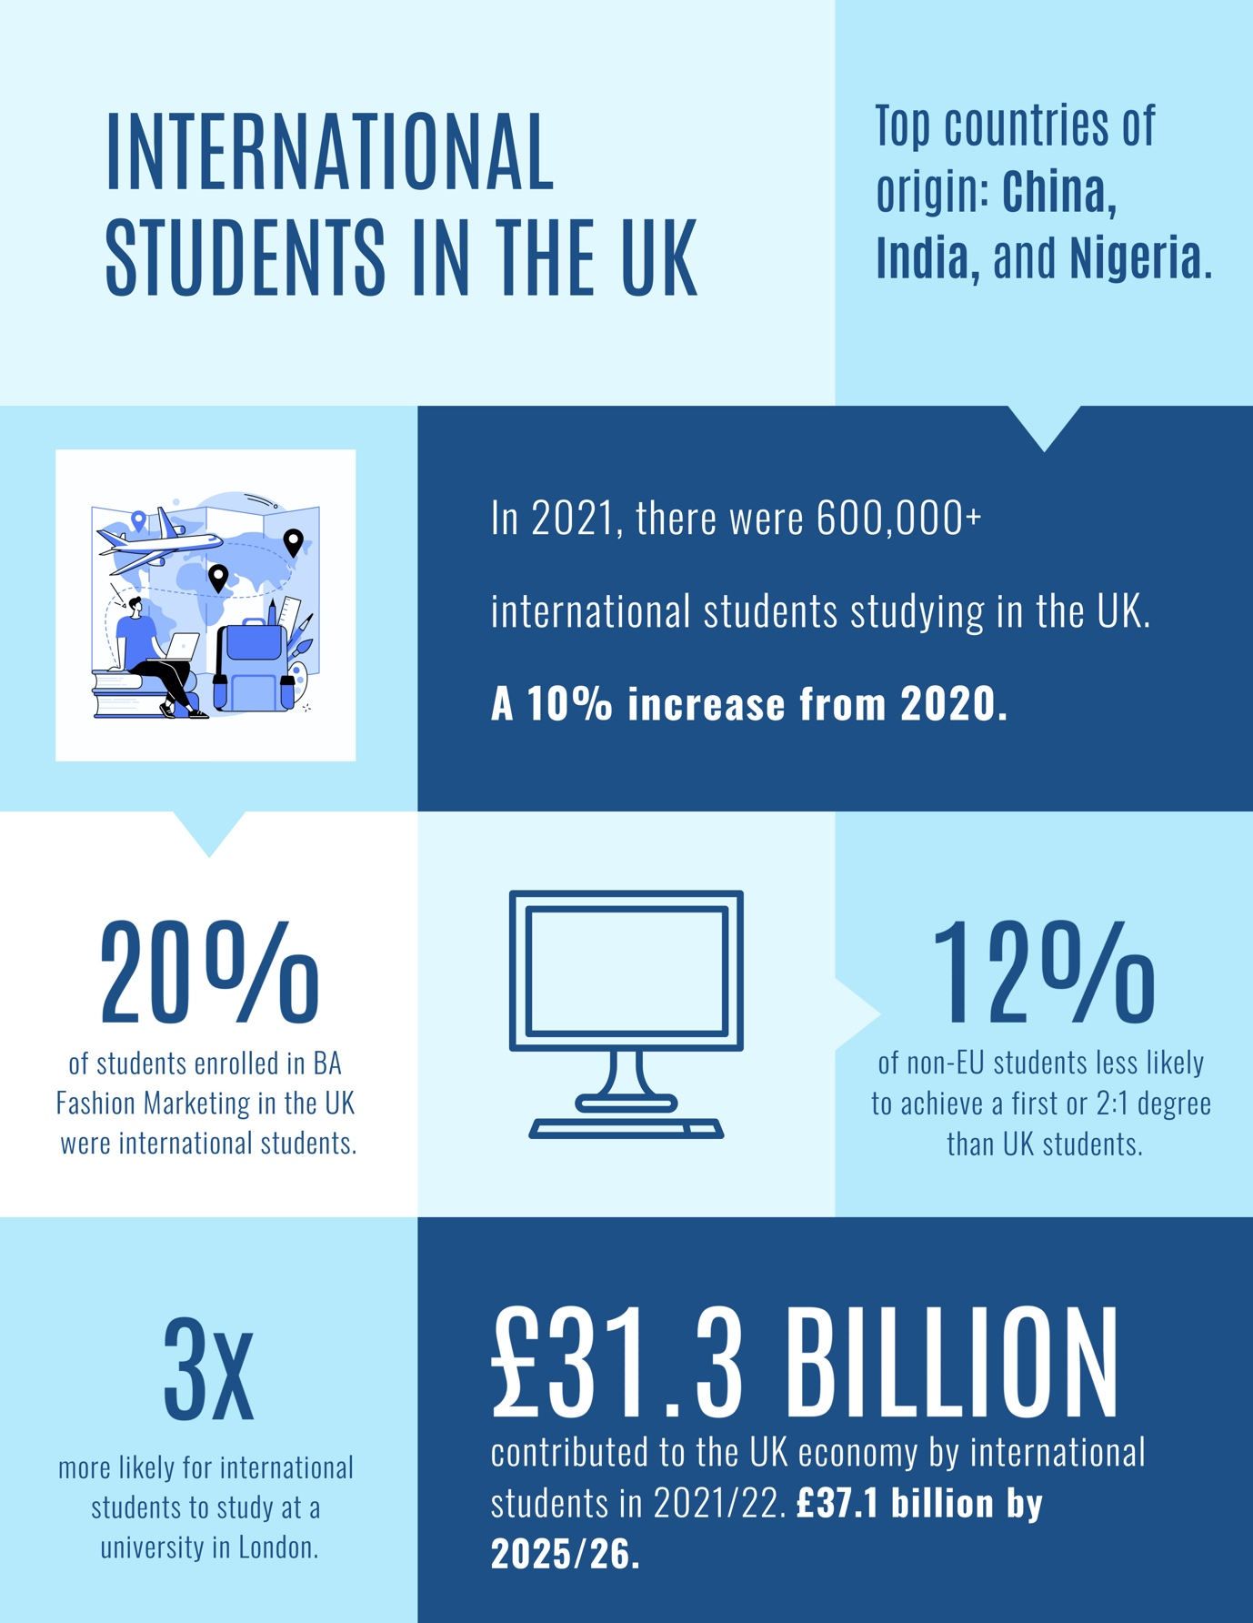
Inclusive learning theory:
The inclusive learning theory that underpins this work is the theory of critical pedagogy. This theory argues that education should be used to challenge social inequalities. An inclusive language glossary can therefore help to challenge social inequalities by providing students with the resources they need to understand and use appropriate academic language. The glossary would also promote collaboration between students and lecturers, which would help to create a more inclusive learning environment.
There are a few supporting measures that can be taken to ensure inclusion. Firstly, lecturers should ensure they explain all the terms being used in class and endeavour to repeat this during the term using various tools such as videos etc., as well as across units to maximise retention and recall.
Lecturers should also be prepared to answer questions from students who are unfamiliar with the terms. Secondly, students should be encouraged to ask questions if they do not understand something. There is no shame in admitting that you might not know something, and asking questions is the best way to learn. Finally, having resources available online and in libraries that can help students learn about marketing terms and acronyms.
It is important for students to feel comfortable asking questions and investigating what terms mean. This will help them to learn the material and to feel more confident in their abilities. It will also help to create a more inclusive learning environment, where all students feel like they belong.
"I was constantly struggling with the language barrier. I had a hard time understanding what my professors were saying, and I was afraid to ask questions." – Hsieh, (2007).

Reflection:
I decided to create an interactive glossary of fashion and marketing terms and abbreviations because I believe that this would be a valuable resource for students. The glossary would allow students to contribute their own knowledge and experiences, which would help to ensure that it is as comprehensive and accurate as possible. It would also allow students to take ownership of the glossary, which would make them more likely to use it.
This was prompted by the paper ‘Ethnicity and Degree Attainment’ that found students from minority ethnic groups were less likely to achieve a degree than white students. The authors argue that this is due, in part, to the use of exclusive language in the classroom, Broecke and Nicholls (2007).
Burke and McManus, (2011), also argue that this use of exclusive language in higher education admissions practices can lead to the exclusion of BAME students. An inclusive language glossary can help to address this issue by providing students with the resources they need to understand and use appropriate academic language.
This resonated with me because I am a person of colour (PoC) and was also considered a Black, Asian, or minority ethnic (BAME) student. However, I was a home student, meaning that I was born and raised in the United Kingdom. Nevertheless, my experiences as a PoC and a BAME student have given me a deep understanding of what it means to be from a different cultural background. This is especially true when coupled with the experience of being from a different, non-English speaking country altogether. As a student, I know that this can be daunting and challenging learning to adapt to a new culture and way of life whilst simultaneously learning a new subject.

Therefore, the idea of an interactive glossary of fashion and marketing terms and abbreviations would be one way to potentially minimise this language disparity. It would be available on various devices to ensure accessibility.

Reasons why an interactive glossary would be considered to promote inclusive learning with the students:
- It would allow students to contribute their own knowledge and experiences. This would help to ensure that the glossary is as comprehensive and accurate as possible, and that it reflects the experiences of a diverse range of people.
- It would allow students to take ownership of the glossary. This would make them more likely to use the glossary and to refer to it when they are writing or speaking in class.
- It would promote collaboration between students and lecturers. Thus, help to create a more inclusive learning environment, where students feel comfortable sharing their ideas and experiences.
- It would be a valuable resource for students who are learning about new content in potentially a second or third language. The glossary would provide them with a comprehensive list of terms and definitions, as well as examples of how to use marketing terms in their own academic work and in industry.

Action:
The glossary would be available online and incorporate terminology from their other units. It would be designed to be accessible on various devices, so that students can access it from anywhere. The glossary would be updated regularly, so that it always reflects the latest language and examples.
Implications for practice:
The creation of an inclusive language glossary would have a number of implications for practice. Firstly, it would help to improve the learning experience for international students. Secondly, it would promote collaboration between students and lecturers. Thirdly, it would help to create a more inclusive learning environment. Finally, it would help to challenge social inequalities.

Being new to university, London and in some instances Western culture can be daunting for international students. Coupling that with a new area of study such as fashion and marketing which uses countless terms and acronyms, it can be hard to keep track of them all. Additionally, some terms are not always explained in class, which can make it even more difficult to understand them. As a result, students may feel uncomfortable or shy about asking questions or investigating what these terms mean.
"Chinese graduate students often face unique challenges when transitioning to a new culture and academic environment. These challenges can include language barriers, cultural differences, and academic expectations." – Zhang, & Li, (2012)
This can be a problem for several reasons. Firstly, it can prevent students from learning the material. If they are unable to understand the vocabularies, they may struggle to follow the lectures or participate fully in discussions. Secondly, it can create a sense of anxiety and isolation. Students may feel like they are the only ones who do not understand the terms, which can in term often lead to them feeling isolated from their classmates.
There are a few measures that can be taken to address this problem. Firstly, lecturers should ensure they explain all the terms being used in class and endeavour to repeat this during the term using various tools such as videos etc., as well as across units to maximise retention and recall.
Lecturers should also be prepared to answer questions from students who are unfamiliar with the terms. Secondly, students should be encouraged to ask questions if they do not understand something. There is no shame in admitting that you might not know something, and asking questions is the best way to learn. Finally, having resources available online and in libraries that can help students learn about marketing terms and acronyms.
It is important for students to feel comfortable asking questions and investigating what terms mean. This will help them to learn the material and to feel more confident in their abilities. It will also help to create a more inclusive learning environment, where all students feel like they belong.

"I was constantly struggling with the language barrier. I had a hard time understanding what my professors were saying, and I was afraid to ask questions." – Hsieh, (2007).
Additionally, the paper ‘Ethnicity and Degree Attainment’ found that students from minority ethnic groups are less likely to achieve a degree than white students. The authors argue that this is due, in part, to the use of exclusive language in the classroom, Broecke and Nicholls (2007).
Burke and McManus, (2011), also argue that this use of exclusive language in higher education admissions practices can lead to the exclusion of BAME students. An inclusive language glossary can help to address this issue by providing students with the resources they need to understand and use appropriate academic language.

Therefore an interactive glossary of fashion and marketing terms and abbreviations would be one way to potentially minimise this language disparity. It would be available on various devices to ensure accessibility.

Reasons why an interactive glossary would be considered to promote inclusive learning with the students:
- It would allow students to contribute their own knowledge and experiences. This would help to ensure that the glossary is as comprehensive and accurate as possible, and that it reflects the experiences of a diverse range of people.
- It would allow students to take ownership of the glossary. This would make them more likely to use the glossary and to refer to it when they are writing or speaking in class.
- It would promote collaboration between students and lecturers. Thus, help to create a more inclusive learning environment, where students feel comfortable sharing their ideas and experiences.
- It would be a valuable resource for students who are learning about new content in potentially a second or third language. The glossary would provide them with a comprehensive list of terms and definitions, as well as examples of how to use marketing terms in their own academic work and in industry.

Carroll, J. (2005) believes the use of explicit language can help to improve learning for all students, including international students. An inclusive language glossary can help to make language more explicit by providing definitions of terms that may be unfamiliar to some students.
In addition to these specific theories, an inclusive language glossary can also be linked to more general theories of inclusive learning, such as the following:
- The theory of critical pedagogy, which argues that education should be used to challenge social inequalities;
- The theory of transformative learning, which argues that learning should lead to personal and social transformation;
- The theory of intercultural competence, which argues that people need to be able to communicate effectively with people from different cultures.

Title: Glossary of Fashion Marketing
Audience: BA Fashion Marketing Year 1 Students
Description: This glossary will define and explain terms related to key terms and language in fashion marketing. The glossary will be accessible to all students, regardless of their language skills or cultural background. There will be use of images, frameworks, audio definitions and written descriptors.
Learning Objectives:
- Understand the importance of using marketing terms;
- Identify terms that are considered to be the academic and industry norm within fashion marketing;
- Reduce dissonance;
- Learn how to use inclusive language in their own marketing writing and speech.

Method:
Padlet is a great tool for creating a glossary for marketing and fashion. It is a free UAL approved online platform that allows creation of interactive walls text, images, videos, and links can be added. This makes it a collaborative way to create a glossary that is visually appealing and easy to navigate.

Benefits of using Padlet:
- Padlet is a user-friendly platform that allows search via the ctrl f feature;
- It is collaborative, students and staff can be invited to collaborate on the glossary, which is a great way to get feedback and to keep the glossary up-to-date;
- Allows anonymity so students do not feel added peer pressure when posting;
- It can be set up with moderator privileges, so all additions are approved and therefore factually correct;
- It is customisable to match the unit or course branding requirements;
- It can be linked to lecture slides so students can click through to glossary directly;
- It is accessible on all devices, so students can access the glossary from anywhere.
Potential limitations:
- Security: Padlets are public by default, so anyone with a link or password could access the content.
- Accessibility: Padlets can only be accessed with an internet connection – therefore an offline version or pdf might also be needed.
- Accessibility: lecture and seminar slides often convert into PDFs when uploaded to Moodle and therefore might not allow clickable keywords linking directly to Padlet glossary.
- Scalability: Padlets can become difficult to manage if there is a large number of entries.

References:
- Hsieh, M.-H. (2007). Challenges for international students in higher education: One student's narrated story of invisibility and struggle. College Student Journal, 41(2), 379-391.
- Eckes, S. E., & Ochoa, T. A. (2007). Students with disabilities: Transitioning from high school to higher education. New York: Routledge.
- Zhang, J., & Li, Y. (2018). Transitioning challenges faced by Chinese graduate students. Journal of International Students, 8(2), 328-341.
- Burke, P. J., & McManus, J. (2011). ‘Art for a few: Exclusions and misrecognitions in higher education admissions practices’. Sociology. 45(1), 77-95.
- Broecke, S., & Nicholls, T. (2007). ‘Ethnicity and Degree Attainment’. British Educational Research Journal. 33(6), 877-898.
- Carroll, J. (2005). ‘Strategies for becoming more explicit’. In J. Carroll & J. Ryan (Eds.), Teaching international students: improving learning for all. London: Routledge.

Infographics refs:
- Higher Education Policy Institute: https://www.hepi.ac.uk/
- Advance HE: https://www.advance-he.ac.uk/
- Universities UK: https://www.universitiesuk.ac.uk/

